**CSA4724 – DEEP LEARNING FOR NUTRITION ANALYSIS**

**HABEEB MOHAMED KASIM M**

**REG NO : 192224093**

**DAY 01 – 21.06.2024**

01.

import numpy as npfrom sklearn.metrics import confusion_matriximport seaborn as snsimport matplotlib.pyplot as pltactual = np.array( ['Defective','Defective','Defective','Not Defective','Defective','Not Defective','Defective','Defective','Not Defective','Not Defective'])predicted = np.array( ['Defective','Not Defective','Defective','Not Defective','Defective','Defective','Defective','Defective','Not Defective','Not Defective'])cm = confusion_matrix(actual,predicted)sns.heatmap(cm, annot=True, fmt='g', xticklabels=['Defective','Not Defective'], yticklabels=['Defective','Not Defective'])plt.ylabel('Prediction',fontsize=13)plt.xlabel('Actual',fontsize=13)plt.title('Confusion Matrix',fontsize=17)plt.show()

OUTPUT

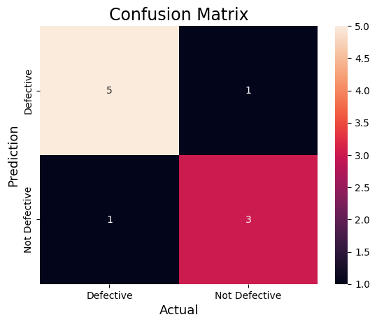

02.

#Import the necessary librariesfrom sklearn.datasets import load_breast_cancerfrom sklearn.model_selection import train_test_splitfrom sklearn.tree import DecisionTreeClassifierfrom sklearn.metrics import confusion_matriximport seaborn as snsimport matplotlib.pyplot as pltfrom sklearn.metrics import accuracy_score, precision_score, recall_score, f1_scoreX, y= load_breast_cancer(return_X_y=True)X_train, X_test, y_train, y_test = train_test_split(X, y,test_size=0.25)tree = DecisionTreeClassifier(random_state=23)tree.fit(X_train, y_train)y_pred = tree.predict(X_test)cm = confusion_matrix(y_test,y_pred)sns.heatmap(cm, annot=True, fmt='g', xticklabels=['malignant', 'benign'], yticklabels=['malignant', 'benign'])plt.ylabel('Prediction',fontsize=13)plt.xlabel('Actual',fontsize=13)plt.title('Confusion Matrix',fontsize=17)plt.show()accuracy = accuracy_score(y_test, y_pred)print("Accuracy :", accuracy)precision = precision_score(y_test, y_pred)print("Precision :", precision)recall = recall_score(y_test, y_pred)print("Recall :", recall)F1_score = f1_score(y_test, y_pred)print("F1-score :", F1_score)

OUTPUT

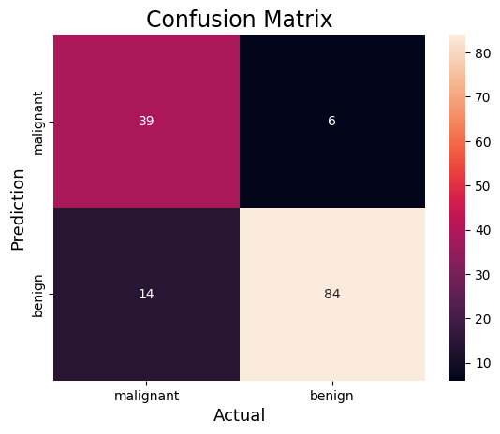

Accuracy : 0.8601398601398601Precision : 0.9333333333333333Recall : 0.8571428571428571F1-score : 0.8936170212765957

03.

from sklearn.datasets import load_digitsfrom sklearn.model_selection import train_test_splitfrom sklearn.ensemble import RandomForestClassifierfrom sklearn.metrics import confusion_matriximport seaborn as snsimport matplotlib.pyplot as pltfrom sklearn.metrics import accuracy_score, precision_score, recall_score, f1_score X, y= load_digits(return_X_y=True)X_train, X_test, y_train, y_test = train_test_split(X, y,test_size=0.25) clf = RandomForestClassifier(random_state=23)clf.fit(X_train, y_train)y_pred = clf.predict(X_test)cm = confusion_matrix(y_test,y_pred)sns.heatmap(cm, annot=True, fmt='g')plt.ylabel('Prediction',fontsize=13)plt.xlabel('Actual',fontsize=13)plt.title('Confusion Matrix',fontsize=17)plt.show()accuracy = accuracy_score(y_test, y_pred)print("Accuracy :", accuracy)

OUTPUT:

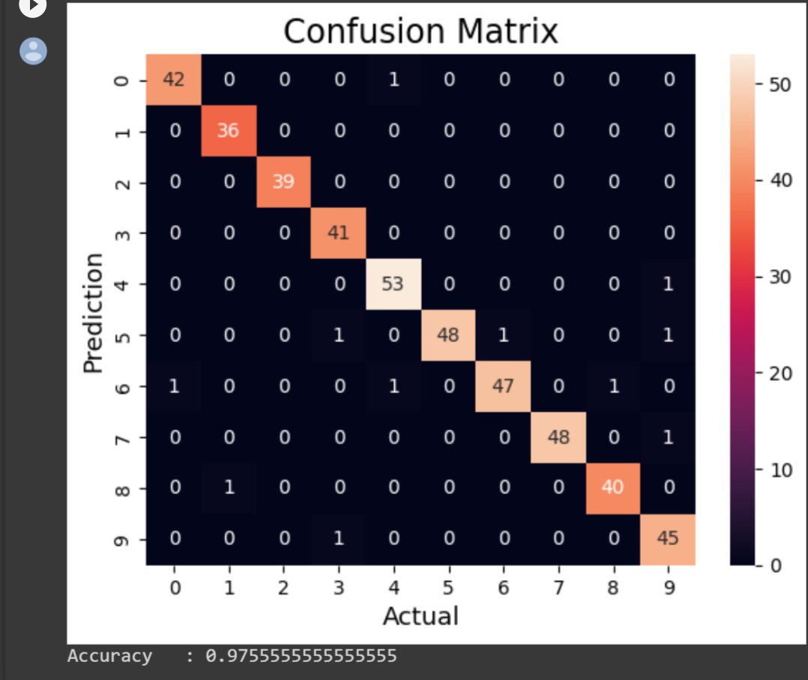

04.

import numpy as npimport matplotlib.pyplot as pltfrom sklearn.pipeline import Pipelinefrom sklearn.preprocessing import PolynomialFeaturesfrom sklearn.linear_model import LinearRegressionfrom sklearn.model_selection import cross_val_scoredef true_fun(X): return np.cos(1.5 * np.pi * X)np.random.seed(0)n_samples = 30degrees = [1, 4, 15]X = np.sort(np.random.rand(n_samples))y = true_fun(X) + np.random.randn(n_samples) * 0.1plt.figure(figsize=(14, 5))for i in range(len(degrees)): ax = plt.subplot(1, len(degrees), i + 1) plt.setp(ax, xticks=(), yticks=()) polynomial_features = PolynomialFeatures(degree=degrees[i], include_bias=False) linear_regression = LinearRegression() pipeline = Pipeline( [ ("polynomial_features", polynomial_features), ("linear_regression", linear_regression), ] ) pipeline.fit(X[:, np.newaxis], y) scores = cross_val_score( pipeline, X[:, np.newaxis], y, scoring="neg_mean_squared_error", cv=10 ) X_test = np.linspace(0, 1, 100) plt.plot(X_test, pipeline.predict(X_test[:, np.newaxis]), label="Model") plt.plot(X_test, true_fun(X_test), label="True function") plt.scatter(X, y, edgecolor="b", s=20, label="Samples") plt.xlabel("x") plt.ylabel("y") plt.xlim((0, 1)) plt.ylim((-2, 2)) plt.legend(loc="best") plt.title( "Degree {}\nMSE = {:.2e}(+/- {:.2e})".format( degrees[i], -scores.mean(), scores.std() ) )plt.show()

OUTPUT:

